SHRI PANCHAM KHEMRAJ MAHAVIDYALAYA, SAWANTWADI
DEPARTMENT OF COMPUTER SCIENCE
PRACTICAL NO. : 1 | ROLL NO. : | TCS-513
SUBJECT: Data Science | CLASS : | TYCS
AIM : Introduction to Excel :  - Perform conditional formatting on a dataset using various criteria.  - Create a pivot table to analyze and summarize data.  - Use the VLOOKUP function to retrieve information from a different  - worksheet or table.  - Perform what-if analysis using Goal Seek to determine input values for  - desired output. | DATE : | / / 2025
SOFTWARE USED : IDLE. | TEACHER SIGNATURE

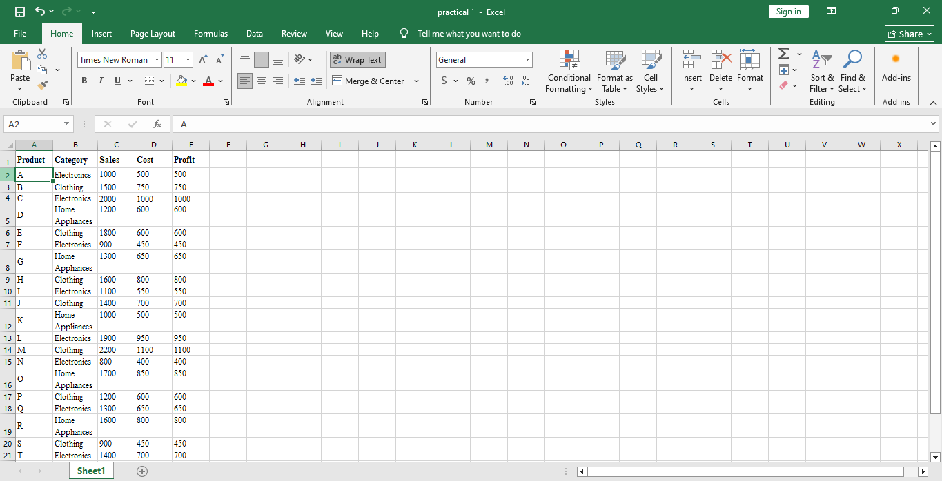
1st

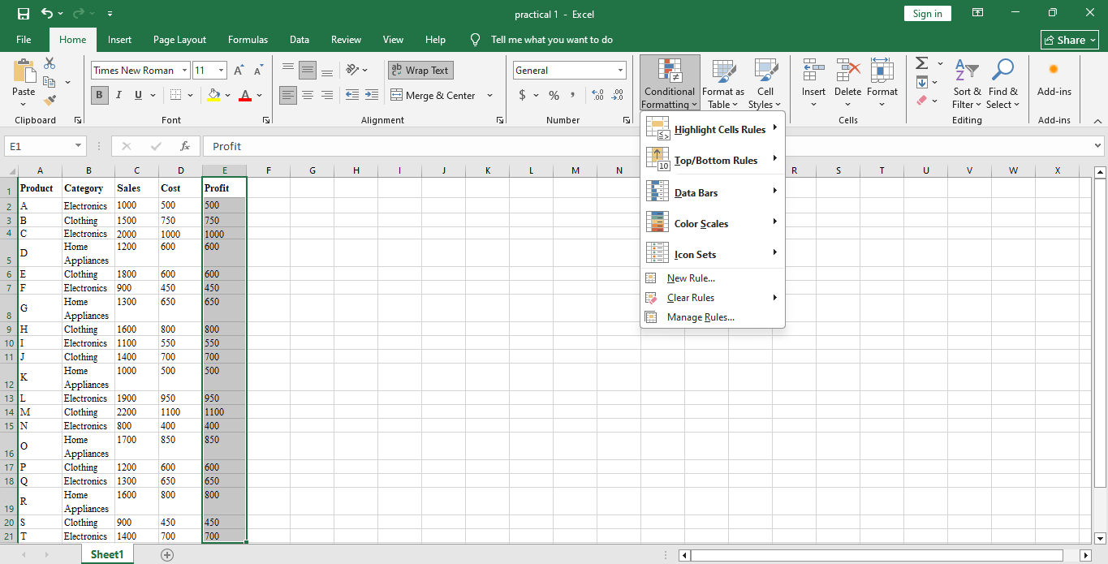
2nd

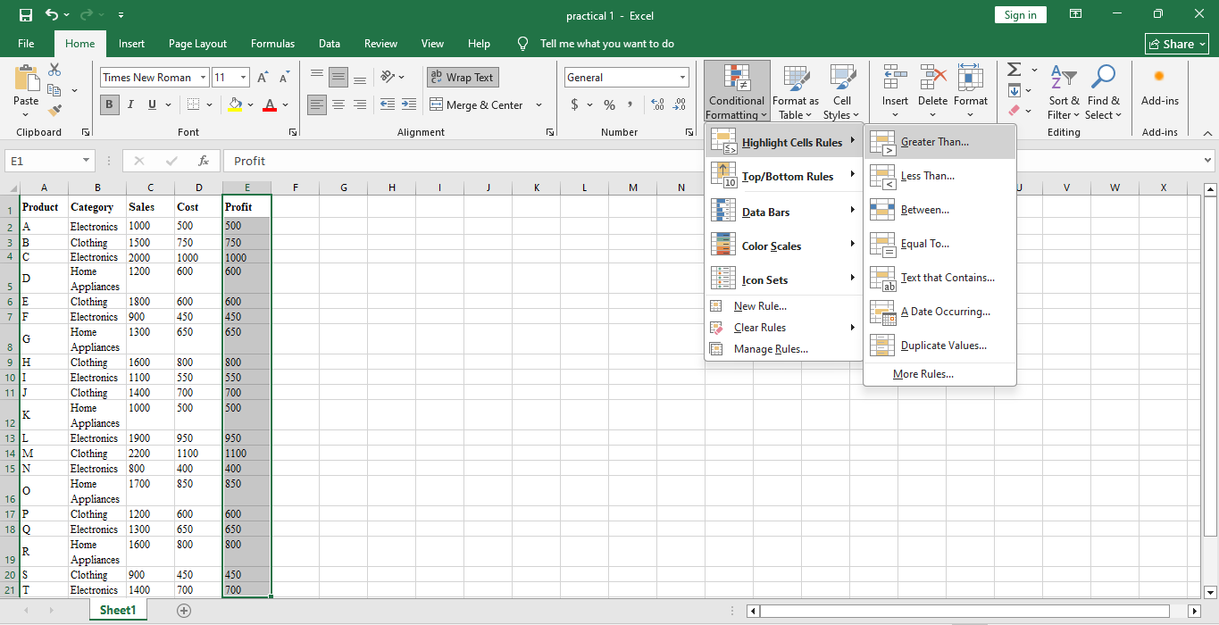
3rd

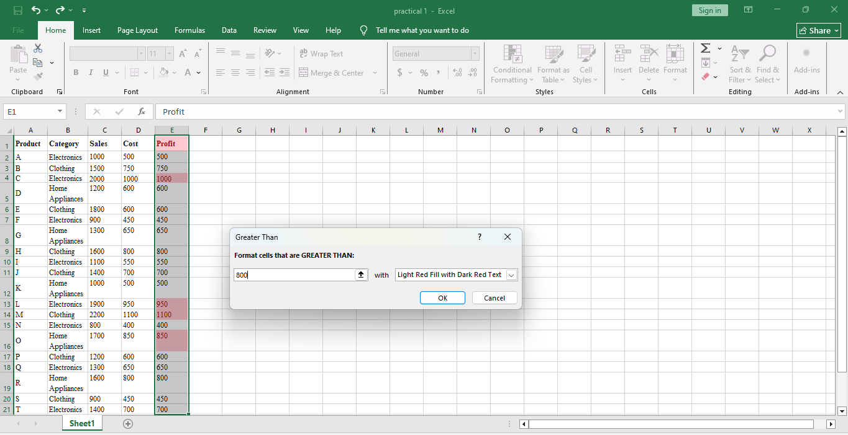
4th

5th
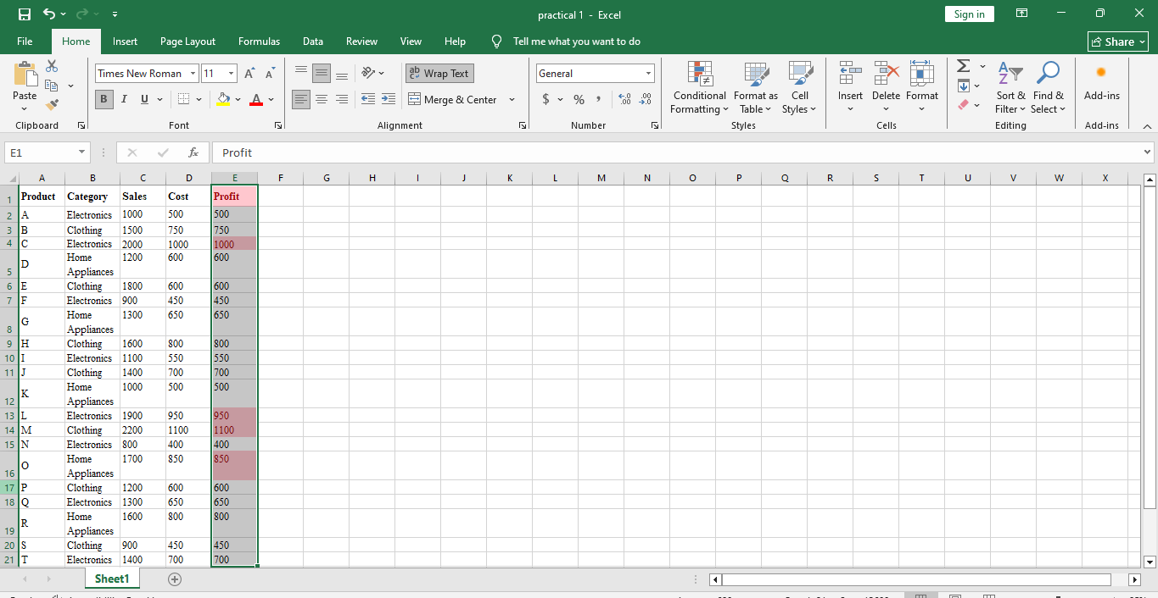

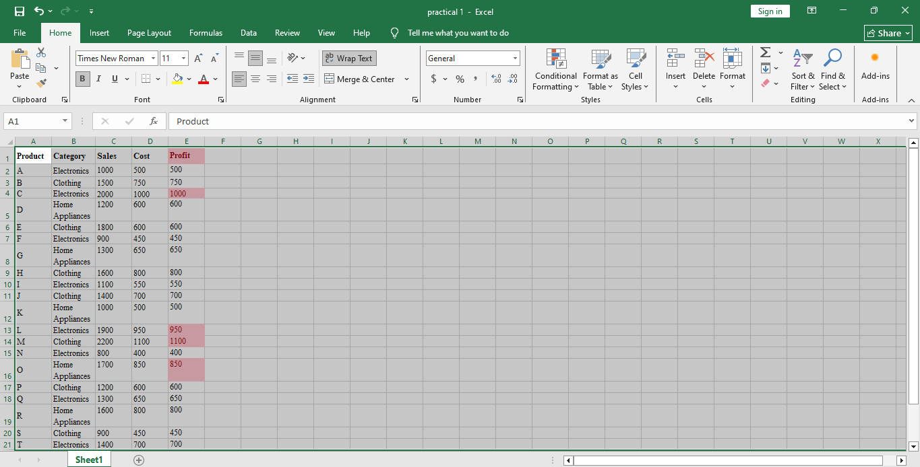
6th

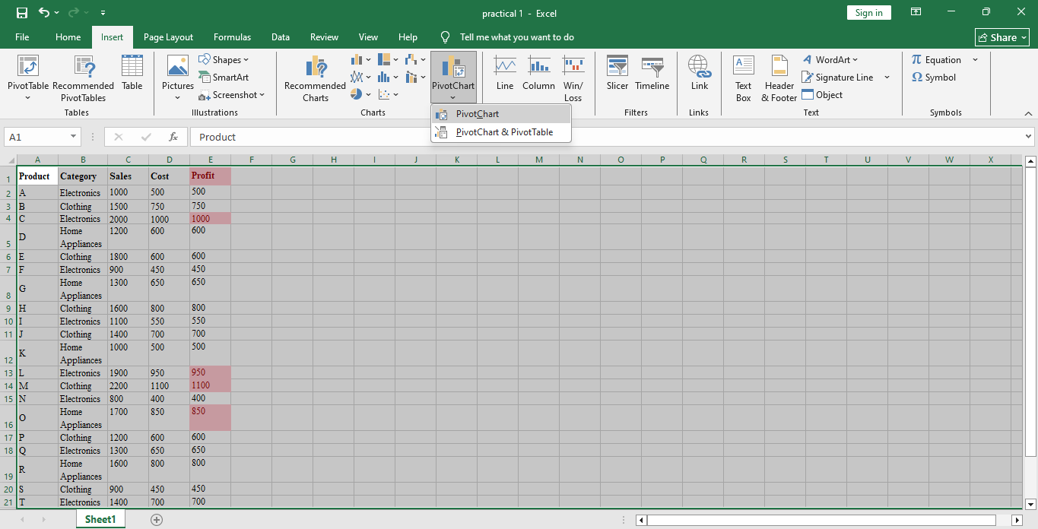
7th

8th
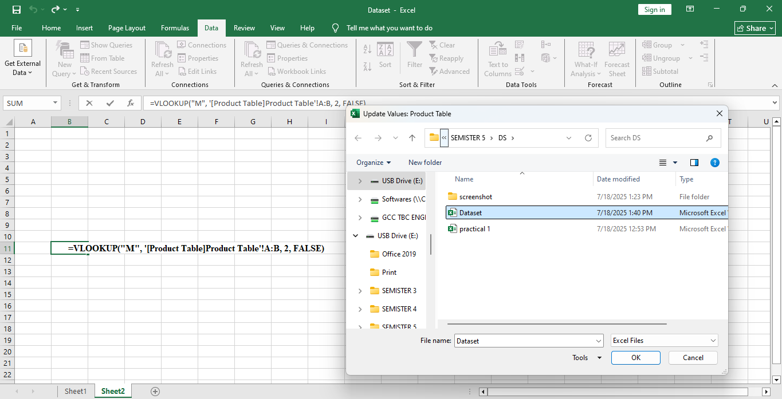

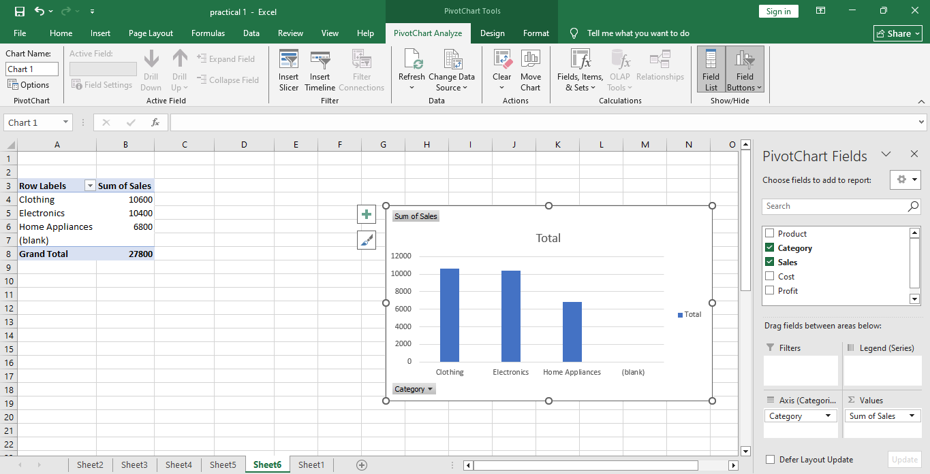
9th

10th

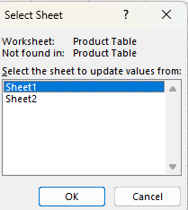

11th
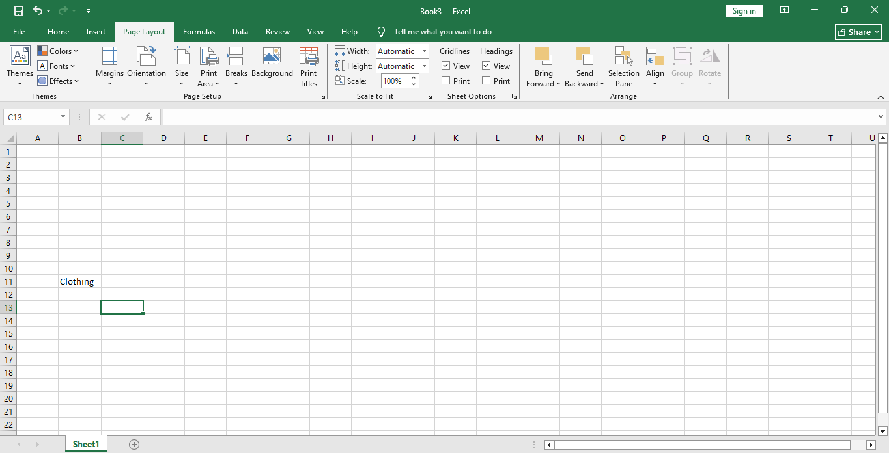

12th
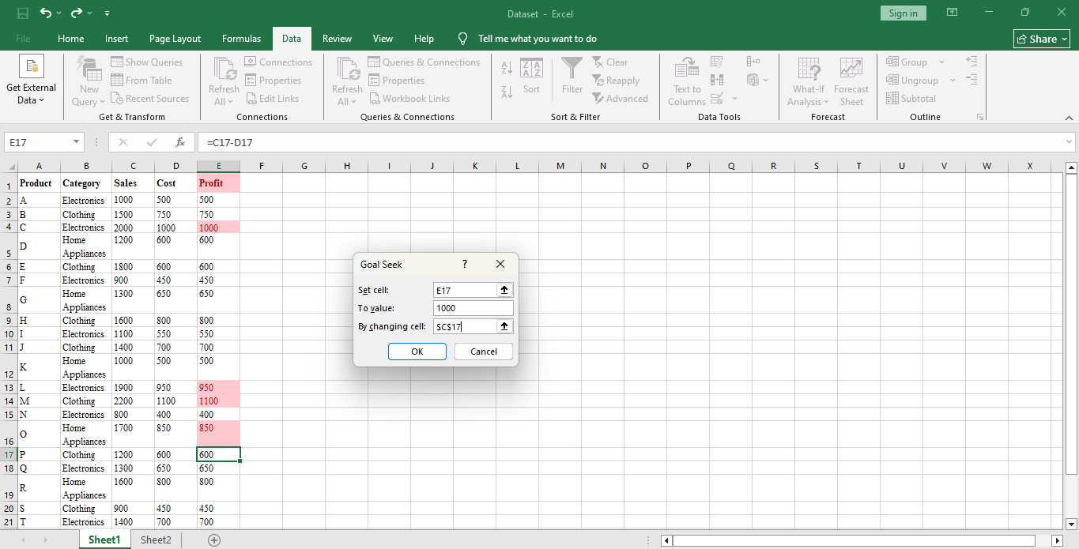

13th
